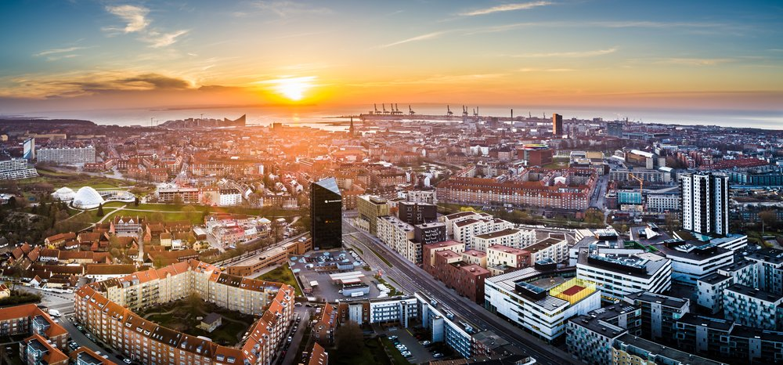

Dear Stephan  
A Warm Welcome to Aarhus – Your New Home!

We hope this letter finds you settling in comfortably in Aarhus!   
  
On behalf of our beautiful city, we are pleased to extend a heartfelt welcome to you. Relocating to a new city and country is undoubtedly exciting yet challenging, and we are thrilled to have you join us here in Aarhus.

|  |  |  |
| --- | --- | --- |
|  | **Explore** [**international.aarhus.dk**](https://direc.to/kN8s) - a website dedicated to internationals, designed to help you navigate and make the most of your city.  This comprehensive platform offers valuable information on various subjects – for instance: | |
|  | * [Learning Danish](https://direc.to/kN2n) – including the free official Danish education * [MitID and Digital Post](https://direc.to/kN2g) * [Studying in Aarhus](https://direc.to/kN8v) * [Childcare and school opportunities](https://direc.to/kN8L) * [Job search](https://direc.to/kN2j) * [Housing](https://direc.to/kN2a) * [Paying bills to the municipality](https://direc.to/kN2Q) * [Traffic and transport](https://direc.to/kN2W) * [Change of foreign driver’s license](https://direc.to/kN2T) * [If leaving Denmark](https://direc.to/kN8H) | * [Socialising and communities](https://direc.to/kN8E) * [Finding a sports or leisure activity  – as an adult or child](https://direc.to/kN8B) * [Finding your next cultural event](https://direc.to/kN8P) * [Events tailored to internationals](https://direc.to/kN2d): join a Newcomers’ Info Evening and our theme-based events that will help you navigate Danish society, and do not miss the biggest event of the year for internationals, Aarhus City Welcome. |

Aarhus is a city rich in history, culture, and innovation, and we are confident that you will find it a welcoming and vibrant place to call home. Whether you are here for work, studying, or other pursuits, we believe that Aarhus has something unique to offer everyone.  
  
As you settle into your new surroundings, we encourage you to embrace the diverse opportunities Aarhus has to offer. Consider contacting local organisations, community groups, clubs, and associations. Engaging with these groups can be a fantastic way to kick-start your social life and enrich your Aarhus experience.  
  
Once again, welcome to Aarhus!   
We are excited to have you as part of our community and wish you a wonderful and fulfilling experience in your new home.